**How to Easily Deploy Your Node.Js App on Heroku**

D:\>**cd heroku-testapp-55**

D:\heroku-testapp-55>**dir**

Volume in drive D is DATA-SSD

Volume Serial Number is 4A3F-E930

Directory of D:\heroku-testapp-55

05/23/2022 04:45 PM <DIR> .

05/23/2022 04:45 PM <DIR> ..

0 File(s) 0 bytes

2 Dir(s) 3,950,067,712 bytes free

D:\heroku-testapp-55>**npm init**

This utility will walk you through creating a package.json file.

It only covers the most common items, and tries to guess sensible defaults.

See `npm help init` for definitive documentation on these fields

and exactly what they do.

Use `npm install <pkg>` afterwards to install a package and

save it as a dependency in the package.json file.

Press ^C at any time to quit.

package name: (heroku-testapp-55)

version: (1.0.0)

description:

entry point: (index.js)

test command:

git repository:

keywords:

author:

license: (ISC)

About to write to D:\heroku-testapp-55\package.json:

{

"name": "heroku-testapp-55",

"version": "1.0.0",

"description": "",

"main": "index.js",

"scripts": {

"test": "echo \"Error: no test specified\" && exit 1"

},

"author": "",

"license": "ISC"

}

Is this OK? (yes)

D:\heroku-testapp-55>**npm install express --save**

39ms (cache miss)

added 57 packages, and audited 58 packages in 1m

7 packages are looking for funding

run `npm fund` for details

found 0 vulnerabilities

a **package.json** file.

{

**"start": "node server.js"**,

"name": "heroku-testapp-55",

"version": "1.0.0",

"description": "",

"main": "**server.js**",

"scripts": {

"test": "echo \"Error: no test specified\" && exit 1"

},

"author": "",

"license": "ISC",

"dependencies": {

"express": "^4.18.1"

}

}

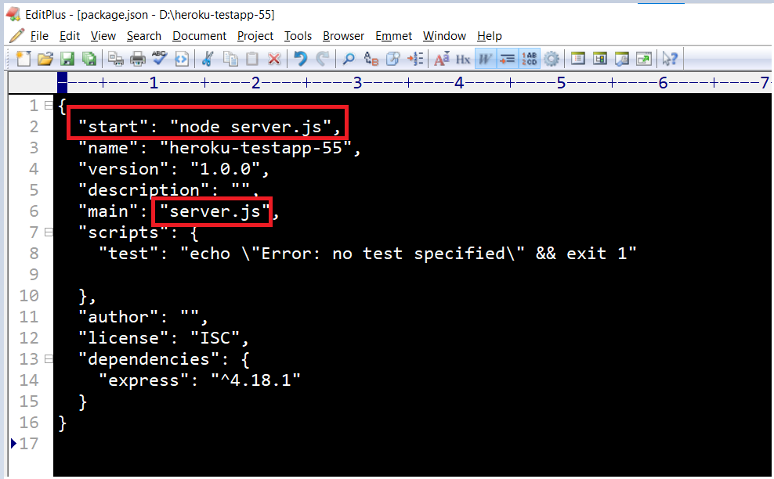

a **server.js** file

const express = require('express');

const app = express();

app.get('/', (req, res) => {

res

.status(200)

.send('Hello server is running')

.end();

});

// Start the server

const PORT = process.env.PORT || 8080;

app.listen(PORT, () => {

console.log(`App listening on port ${PORT}`);

console.log('Press Ctrl+C to quit.');

});

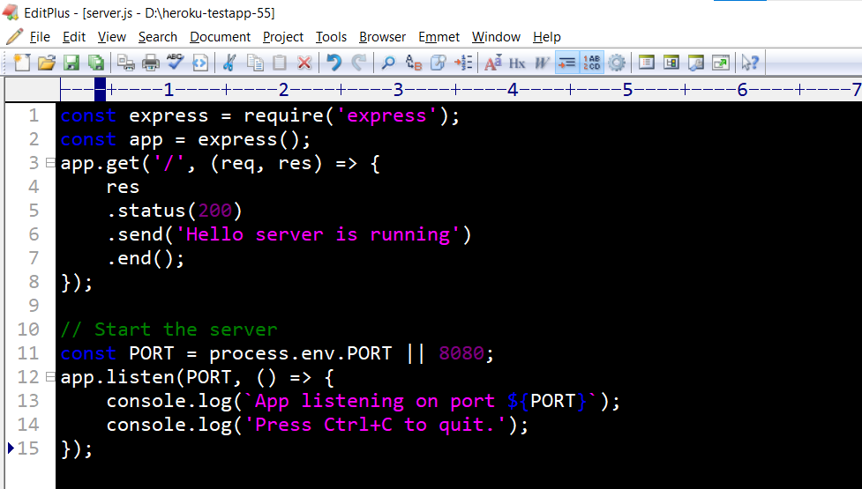

D:\heroku-testapp-55>**npm start**

> heroku-testapp-55@1.0.0 start

> node server.js

**App listening on port 8080**

Press Ctrl+C to quit.

Terminate batch job (Y/N)? **Y**

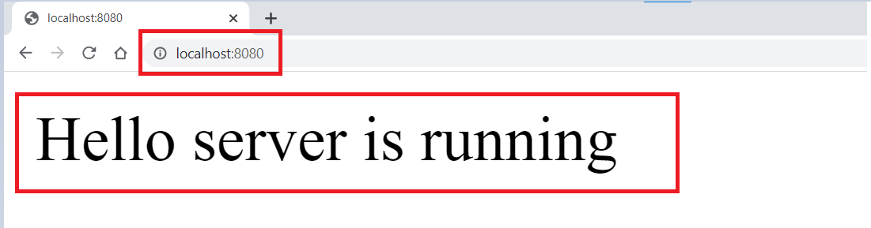

File **Procfile**

web: node server.js

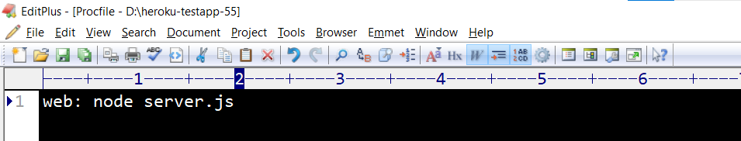

D:\heroku-testapp-55>**heroku login**

» Warning: heroku update available from 7.59.0 to 7.60.2.

heroku: Press any key to open up the browser to login or q to exit:

Opening browser to https://cli-auth.heroku.com/auth/cli/browser/7e459d9b-c1f2-4d0d-9b27-4b7 ac1ac63db?requestor=SFMyNTY.g2gDbQAAAA0xMjMuMjEuMTMwLjQ0bgYAYMUH8YABYgABUYA.Y4uCMTZ16H1OF0G 3gdqMHpcrz3g7rE6RcBc5qJrPOIo

Logging in... done

Logged in as vhho@ualberta.ca

D:\heroku-testapp-55>**git init**

Initialized empty Git repository in D:/heroku-testapp-55/.git/

D:\heroku-testapp-55>**heroku git:remote -a heroku-testapp-55**

» Warning: heroku update available from 7.59.0 to 7.60.2.

set git remote heroku to https://git.heroku.com/heroku-testapp-55.git

D:\heroku-testapp-55>**git add .**

warning: LF will be replaced by CRLF in node_modules/.bin/mime.

The file will have its original line endings in your working directory

warning: LF will be replaced by CRLF in node_modules/.bin/mime.ps1.

…

…

The file will have its original line endings in your working directory

warning: LF will be replaced by CRLF in package.json.bak.

The file will have its original line endings in your working directory

D:\heroku-testapp-55>**git commit -m "your commit message"**

[master (root-commit) 2daa468] your commit message

432 files changed, 62103 insertions(+)

create mode 100644 Procfile

create mode 100644 Procfile.bak

create mode 100644 node_modules/.bin/mime

…

…

create mode 100644 package.json.bak

create mode 100644 server.js

create mode 100644 server.js.bak

D:\heroku-testapp-55>**git push heroku master**

Enumerating objects: 516, done.

Counting objects: 100% (516/516), done.

Delta compression using up to 12 threads

Compressing objects: 100% (492/492), done.

Writing objects: 100% (516/516), 640.35 KiB | 6.67 MiB/s, done.

Total 516 (delta 80), reused 0 (delta 0), pack-reused 0

remote: Compressing source files... done.

remote: Building source:

remote:

remote: -----> Building on the Heroku-20 stack

remote: -----> Determining which buildpack to use for this app

remote: -----> Node.js app detected

remote:

remote: -----> Creating runtime environment

remote:

remote: NPM_CONFIG_LOGLEVEL=error

remote: NODE_VERBOSE=false

remote: NODE_ENV=production

remote: NODE_MODULES_CACHE=true

remote:

remote: -----> Installing binaries

remote: engines.node (package.json): unspecified

remote: engines.npm (package.json): unspecified (use default)

remote:

remote: Resolving node version 16.x...

remote: Downloading and installing node 16.15.0...

remote: Using default npm version: 8.5.5

remote:

remote: -----> Installing dependencies

remote: Prebuild detected (node_modules already exists)

remote: Rebuilding any native modules

remote: rebuilt dependencies successfully

remote: Installing any new modules (package.json)

remote:

remote: up to date, audited 58 packages in 505ms

remote:

remote: 7 packages are looking for funding

remote: run `npm fund` for details

remote:

remote: found 0 vulnerabilities

remote:

remote: -----> Build

remote:

remote: -----> Caching build

remote: - node_modules

remote:

remote: -----> Pruning devDependencies

remote:

remote: up to date, audited 58 packages in 524ms

remote:

remote: 7 packages are looking for funding

remote: run `npm fund` for details

remote:

remote: found 0 vulnerabilities

remote:

remote: -----> Build succeeded!

remote: -----> Discovering process types

remote: Procfile declares types -> web

remote:

remote: -----> Compressing...

remote: Done: 32.2M

remote: -----> Launching...

remote: Released v3

remote: https://heroku-testapp-55.herokuapp.com/ deployed to Heroku

remote:

remote: Verifying deploy... done.

To https://git.heroku.com/heroku-testapp-55.git

* [new branch] master -> master

D:\heroku-testapp-55>

